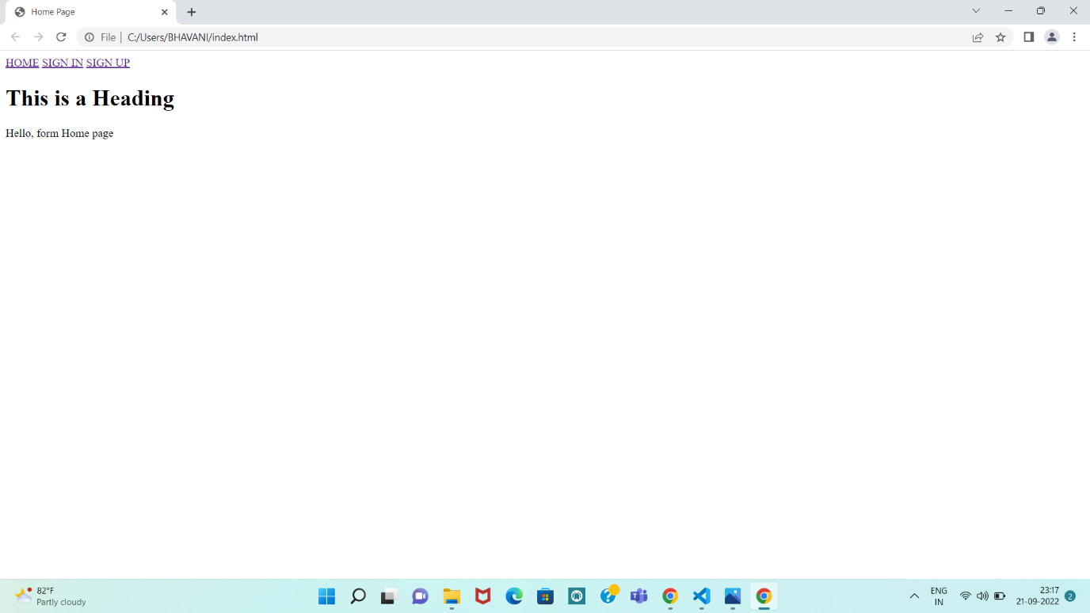

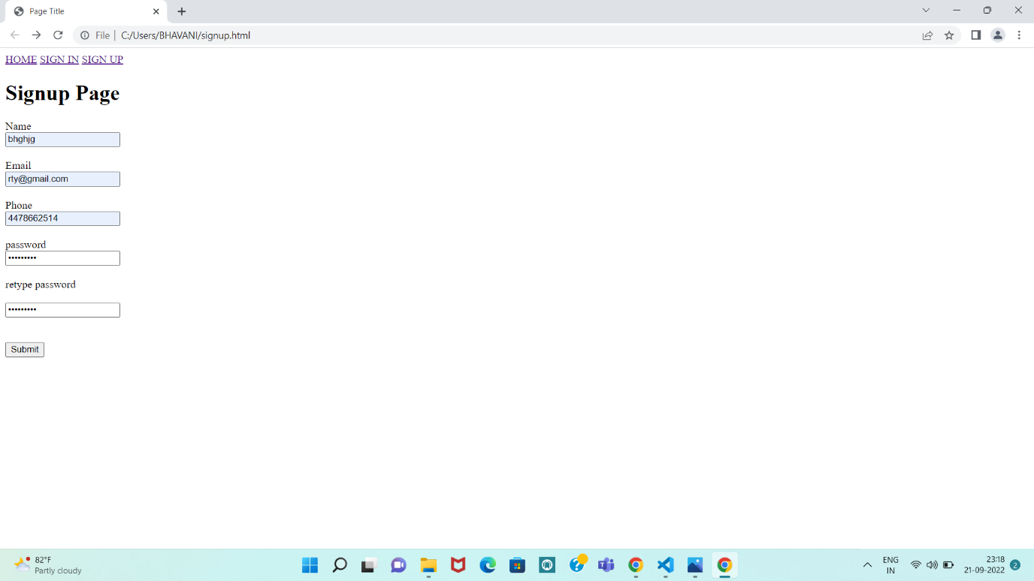

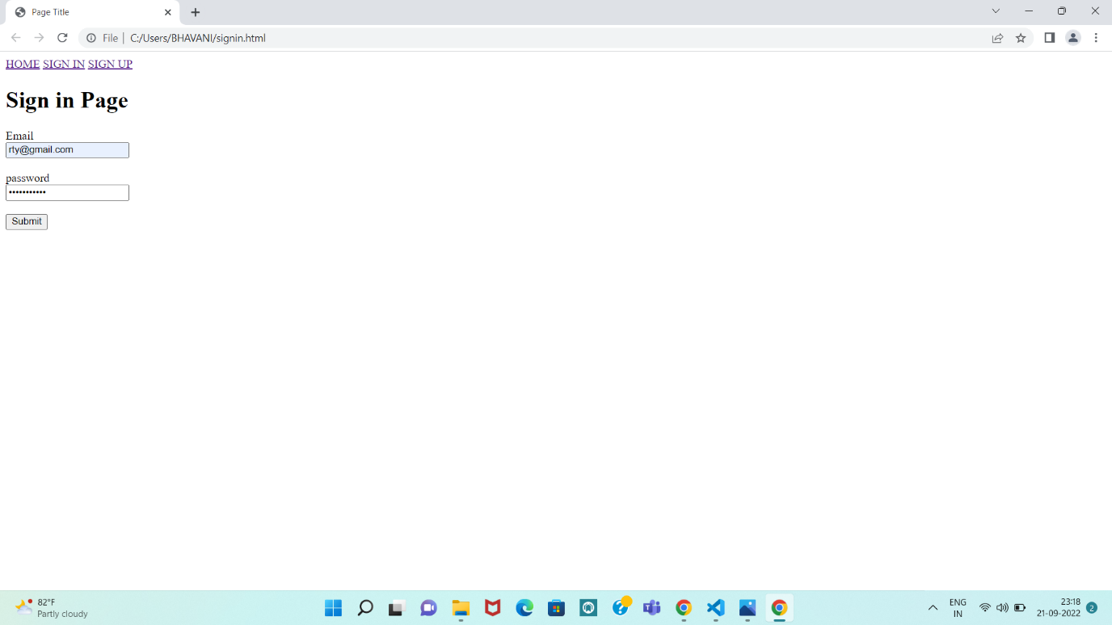

<!-- saved from url=(0080)file:///C:/Users/BHAVANI/Documents/formibm.html?name=&email=&telNo=&description= -->

<html><head><meta http-equiv="Content-Type" content="text/html; charset=windows-1252">

<meta name="viewport" content="width=device-width, initial-scale=1">

<style type="text/css">

body {

background-color: #E6E6FA;

font-family: Arial, Helvetica, sans-serif;

}

\* {

box-sizing: border-box;

}

[input type=text],select,textarea{

padding-top: 50px;

padding-right: 30px;

padding-bottom: 50px;

padding-left: 80px;

margin:10px;

border:1px solid #ccc;

border-radius:4px;

box-sizing:border-box;

}

input[type=sumbit]

{

background-color:#FFEFD5;

color:#AFEEEE;

padding-top: 50px;

padding-right: 30px;

padding-bottom: 50px;

padding-left: 80px;

margin:8px;

border:none;

border-radius:4px;

cursor:pointer;

}

input[type=submit]:hover

{

background-color:#FFEFD5;

}

.container {

border-radius: 5px;

background-color: #f2f2f2;

padding-top: 50px;

padding-right: 30px;

padding-bottom: 50px;

padding-left: 80px;

}

}

</style>

</head>

<body>

<form>

<div align="center">

<label for="name">Name:</label>

<input type="text" id="name" name="name" placeholder="Your name.."><br><br>

<label for="email">Email:</label>

<input type="email" id="email" name="email" plcaeholder="Your email "><br><br>

<label for="telNo">Phone:</label>

<input id="telNo" name="telNo" type="tel"><br><br>

<lable for="description">Message

<textarea id="description" name="description" placehoder="Type something..."></textarea><br><br>&nbsp;

<input type="submit" value="Submit">

</lable></div>

</form>

</body></html>